Group Sessions:
Generosity in Mark’s Gospel

www.generousjune.co.uk

The Generosity of God in Mark’s Gospel

Leaders Notes

As part of Generous June we are exploring what it means to be generous.
When we meet to explore what Mark’s gospel says about generosity,
it is integral to remember it is all about who Jesus is and our response to him.

The teaching of Jesus on our attitudes to others, possessions and lifestyles should not be separated from the challenge to see him for who he is.

We encourage our group leaders to prepare these sessions by reading the whole of Mark’s Gospel. Perhaps encourage your members to do so too, and/or to listen to this year’s Generous June Podcast, which takes a journey through the entire book. The Bible is a key way in which we can hear from God.

Throughout the following four weeks we will see a lot of different situations that present the perception and practical application of what it means to be generous.

- How can we be generous if we have, what the world perceives as, little to give?
- Can we be generous when our plans go astray, and we run out of resources?
- What is our relationship with our wealth and possessions?
- Is being generous with my wealth, possessions, and everything of me, that important?

Let’s not forget, this subject can be extremely challenging. But our hope and prayer is that those that take part in these sessions come away with a refreshed understanding of who Jesus is, and why embodying the expression of generosity he exemplified should be our goal.

Video resources to consider using:
https://www.youtube.com/watch?v=3lfPK2vfC54 Bible Project Overview
https://www.youtube.com/watch?v=62CliEkRCso Bible Project Generosity
https://www.youtube.com/watch?v=hXeb0q3GDfs Cheerful Giver Introduction
https://www.youtube.com/watch?v=4cs0gRxzKpY Francis Chan on Giving
https://www.youtube.com/watch?v=wh40S5XAc2Q Louise’s Generosity story
https://www.youtube.com/watch?v=LiBFufjbVFQ Chuma’s Generosity story

Session 1: The Widow’s Mite
Mark 12:38-44

Starter

Ask the group to split into pairs.

Get them to discuss the following:

- Can they remember any milestones from their life that they consider part of their own journey of giving?
- What did they learn at home about giving, or at school, or their youth group?
- Did things change when they started work – for better or for worse?
- Has church teaching played a part in the giving journey?
- Do they have a plan for the future – perhaps a legacy or a response to a foreseen change of circumstances?

Consider sharing with the group.

Read Mark 12:38-44

Discuss

- Is Jesus’ teaching about how much we should give or the heart with which we give? Can we really separate the two? Someone said it is only godly to give the widow’s mite if we give with the widow’s heart!
- Is Jesus encouraging his disciples to literally give all we have?
  - Consider reading the following to add to the discussion:
    - Luke 18:18-25
    - Luke 19:1-10
    - Leviticus 27:30
    - 2 Corinthians 8:12
- Jesus pointed out the widow’s giving to his disciples, not the crowd. Are disciples expected to be particularly generous? Might that expectation extend to church leaders?
- Are wealthy people expected to give more or less than poor people?

Session 1: Page 1

- To what extent should Christian giving be sacrificial? Should the
church have to coax money from its members?

Share a copy of the graphic below for discussion–
- Where do people think they are on the Six Steps of Christian Giving?
- Where would they like to be?

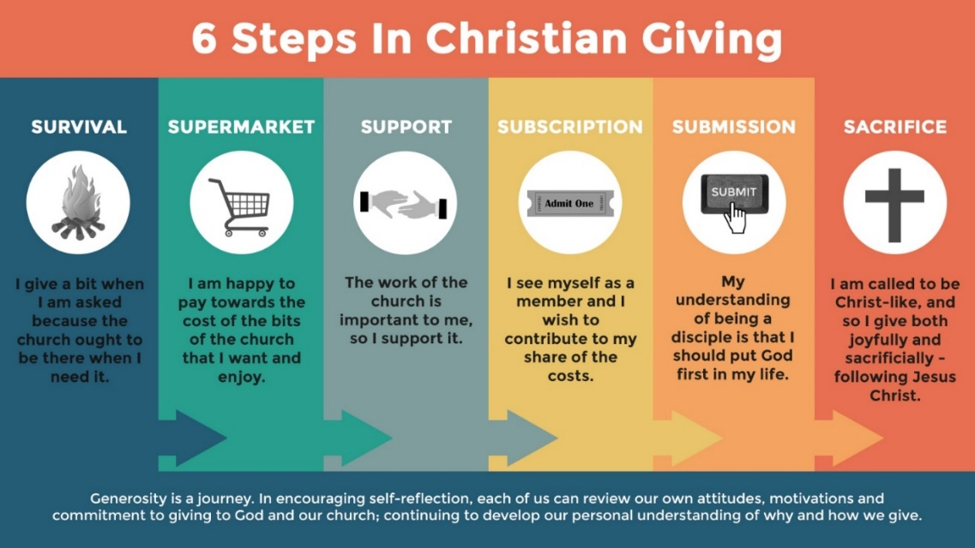

So What?

What can we learn from today?

- Individually
  - Is there anything we can do personally around our own use of money, our giving and our finances that would more greatly reflect Jesus’ teachings?
- As a Church
  - What can our Church do better to help members, old and new, to think about the role and relationship between money and faith?
- As a wider community
  - What examples of generosity have we seen in the media? How is this good news reported and received?

Session 1: Page 2
Session 1: Page 2

Reflect

Living For Your Glory – Tim Hughes

Tim Hughes - Living For Your Glory - YouTube

Consider listening to this song together.

Pray

Ask the group to pray individually about their response to the session today, and about their own response to financial giving. Pray together that God would provide more opportunities for the group to be generous and to consider their own responses to giving.

Closing Prayer
Lord Jesus Christ, we present ourselves to you as an offering of all that we are and all that we have. May we daily be transformed by the Spirit at work within us, that our whole lives may be worship which is pleasing and acceptable to you our Lord and Redeemer. Amen.

Session 1: Page 3
Session 1: Page 3
Session 2: Feeding of the Five Thousand
Mark 6:30-44

Starter

- Ask the group: Have you ever had an experience of God unexpectantly
meeting your needs?
- Ask the group: Have you ever found yourself wanting to respond to a great need, but have felt what that what you could offer might make little difference?

Read Mark 6:30-44

Discuss

- The disciples were seeking solitude and were weary. They were followed by needy people – how can you keep giving when you feel drained? What example should we follow here?
- Would you follow Jesus into the wilderness with no food or sustenance? How important is hearing Jesus’ teaching to you?
- This miracle appears in all four gospels, the only miracle to do so. Why is that do you think?
    - Consider looking at the story of the manna in Exodus 16 and see what similarities you can find.
- What do you think this passage tells us about the relationship between physical need and spiritual need?
    - What is Jesus’ approach to this?
- What is our response when we feel that God doesn’t provide for our needs?

So What?

What can we learn from today?

- Individually
  - What relationship do we have with food and thanksgiving? Does this remain important in a world where we have plenty?

Session 2: Page 1
- As a Church
  - What can we do to ensure we are listening to the word of
God and getting the spiritual sustenance we need?

- As a wider community
  - What is our response to those that do go hungry in our
communities? Are we even aware that there are those suffering
in this way and what help they can receive?

Reflect

Knowing You – Graham Kendrick

https://www.youtube.com/watch?v=4r8XfE_VNb0

Consider listening to this song together.

Pray

Pray together for those you know of that lack in spiritual sustenance and those that are hungry in our communities and across our world. Pray that God would provide all that they need.

Closing Prayer
Almighty God whose love is revealed in Jesus Christ your Son, may we who have responded by faith to your call so order our lives that they are built on your wisdom. Grant that as we respond to your love we may grow into your likeness. Create in us loving and generous hearts that we may respond to your call upon our lives. Amen.

Session 2: Page 2
Session 3: The Way of the Cross
Mark 8: 31-38

Starter

Ask the group to divide into pairs or threes and read the following poem:

I don’t want a splintered Messiah
in a sweat-stained, greasy grey robe
I want a new one
I couldn’t take this one to parties
people would say ‘who’s your friend?’
I’d give an embarrassed giggle and change the subject
If I took him home I’d have to bandage his hands
The neighbours would think he’s a football hooligan
I don’t want his cross in the hall
it doesn’t go with the wallpaper
I don’t want him standing there
like a sad ballet dancer with holes in his tights
I want a different Messiah
streamlined and inoffensive
I want one from a catalogue
who’s as quiet as a monastery
I want a package tour Messiah
not one who takes me to Golgotha
I want a King of Kings
with blow-waves in his hair
I don’t want the true Christ
I wanna false one.

‘Splintered Messiah' written by Stewart Henderson

Ask them to consider the following questions:

- In what ways do we prefer a false Christ to the real one?
- In what ways does our church seem to depict a false Christ as opposed
to the real one?

Session 3: Page 1

Read Mark 8:31-38

Discuss

The passage contains two challenging statements:
‘Whoever wants to be my disciple must deny themselves’ and
‘what good is it for someone to gain the whole world yet forfeit their soul’.

• Ask each group member to suggest one thing he or she likes to do, play, watch, purchase and so on. Is Jesus saying that to enjoy these things we are not denying ourselves but instead losing our souls? If we disagree, can we say why?

• Jesus calls us here to lay down our lives. Is he being literal or is this for the first disciples only? If not, what does this mean for the choices we make in how we live our lives here and now?

• When it comes to our finances and possessions, is understanding that all we have is a gift from God a biblical and helpful way for us to think? Why is this problematic for some people?

Reconsider the Six Steps of Christian Giving – does the discussion we have just read help us understand this tool in a different way?
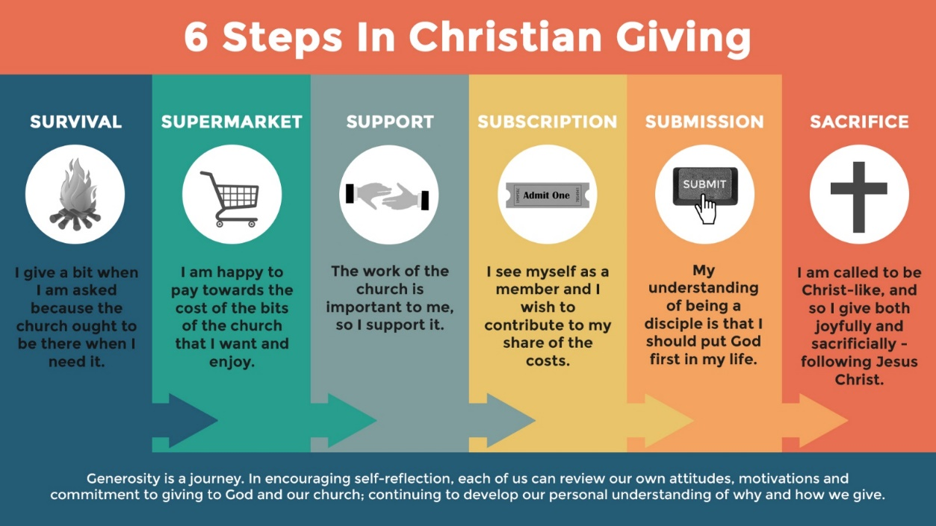

Session 3: Page 2

So What?

What can we learn from today?

- Individually
  - Consider Matthew 6:21 – “Where your treasure is, there your
heart will be also”.
  - What could we re-evaluate considering this passage?

- As a Church
  - How does our church navigate responding to a consumer society that is focused on self-gratification?

- As a wider community
  - How do we respond to advertisements and social media that emphasise this culture?

Reflection

All to Jesus, I Surrender - Judson W. Van DeVenter

https://www.youtube.com/watch?v=SW8EA7DEQ2M

Consider listening to the song as a group.

Pray

Ask people to pray in silence. Encourage them to personally reflect on today’s session and their own response.

Closing prayer
Lord Jesus, you have called us to follow you. As we consider how we respond to your love grant that we may be generous, faithful, and responsible stewards of all that you have entrusted to us. Amen.

Session 3: Page 3
Session 4: The Great Commandment
Mark 12:28-34

Starter

Ask the groups to break into twos or threes and discuss the following
questions:
- Have you ever received unexpected generosity?
  - What it anonymous?
  - How did it make you feel?
  - Were you encouraged to pass on this generosity?
- Have you ever found yourself prompted to give generously - especially from or to someone outside your own family or close friendship group?
  - Did you feel you were prompted by God or other things?
  - How did it feel to be generous and loving in this way?

Read Mark 12:28-34

Discuss

If we did not have this passage in the Bible, would our view of what is the most important commandment be different? Why?
• We are called to love God with heart, soul, mind and strength.
- Break down what each of these words mean to the group and how each relates, in a practical way, to loving God.
• How do we love a neighbour we don’t get on with, or don’t know?
• What does it mean to love God with all that we are when it comes to our wealth and possessions?
- Read 1 Tim 6:17-19. Ask the group to identify the key words in the passage which help us develop a healthy attitude to money – amongst them are contentment, giving and gratitude. How can these words directly relate to our wealth and possessions?
• What do you think Jesus meant by ‘You are not far from the Kingdom of God’?

Session 4: Page 1

So What?

- Individually
  - How can we develop practical ways to be disciples with
our financial lives? How can you share ways to grow as
generous givers, to learn contentment, practise gratitude
and be free from the trappings of a consumer society?
- As a Church
  - Our giving resources the ministry and mission of our church. How can we understand the importance of giving to our church as a priority?
  - Does it help to think about this in terms of why and how we give to other charities?

- As a wider community
  - In what ways can we embody “Love Your Neighbour” in a practical way?
  - How can we do this on our doorstep, across our towns and cities, or even across country borders?

Reflection

I Will Offer Up My Life - Matt Redman

https://www.youtube.com/watch?v=kQkzHwz2eLE

Consider listening to the song as a group.

Pray

Read verses 29-31 aloud together. Follow this with a time of silence to give an opportunity to confess and repent of times when this has not been followed and then lead the group in a prayer asking for help to keep this commandment.

Encourage one another to pray for the others in the group, for their own journey of faith and their own relationships with finances. Pray for one another that we would receive the support from God to love our neighbours. Pray for the support from God to love him with all our hearts, soul, mind and strength.

Session 4: Page 2
Closing prayer
Heavenly Father, you are the God of all people. You have called us to
serve the poor, grant to us a humble spirit of understanding and
service, that we may stand alongside the poor; that we may challenge
those things which oppress and affirm those things that set free those
who are imprisoned by poverty of body and spirit. This we ask in the name
your Son, our Lord. Amen.

Session 4: Page 3
This Bible study was inspired by Generous God Generous People, a comprehensive resource developed by the Diocese St Edmundsbury and Ipswich, used with thanks.

