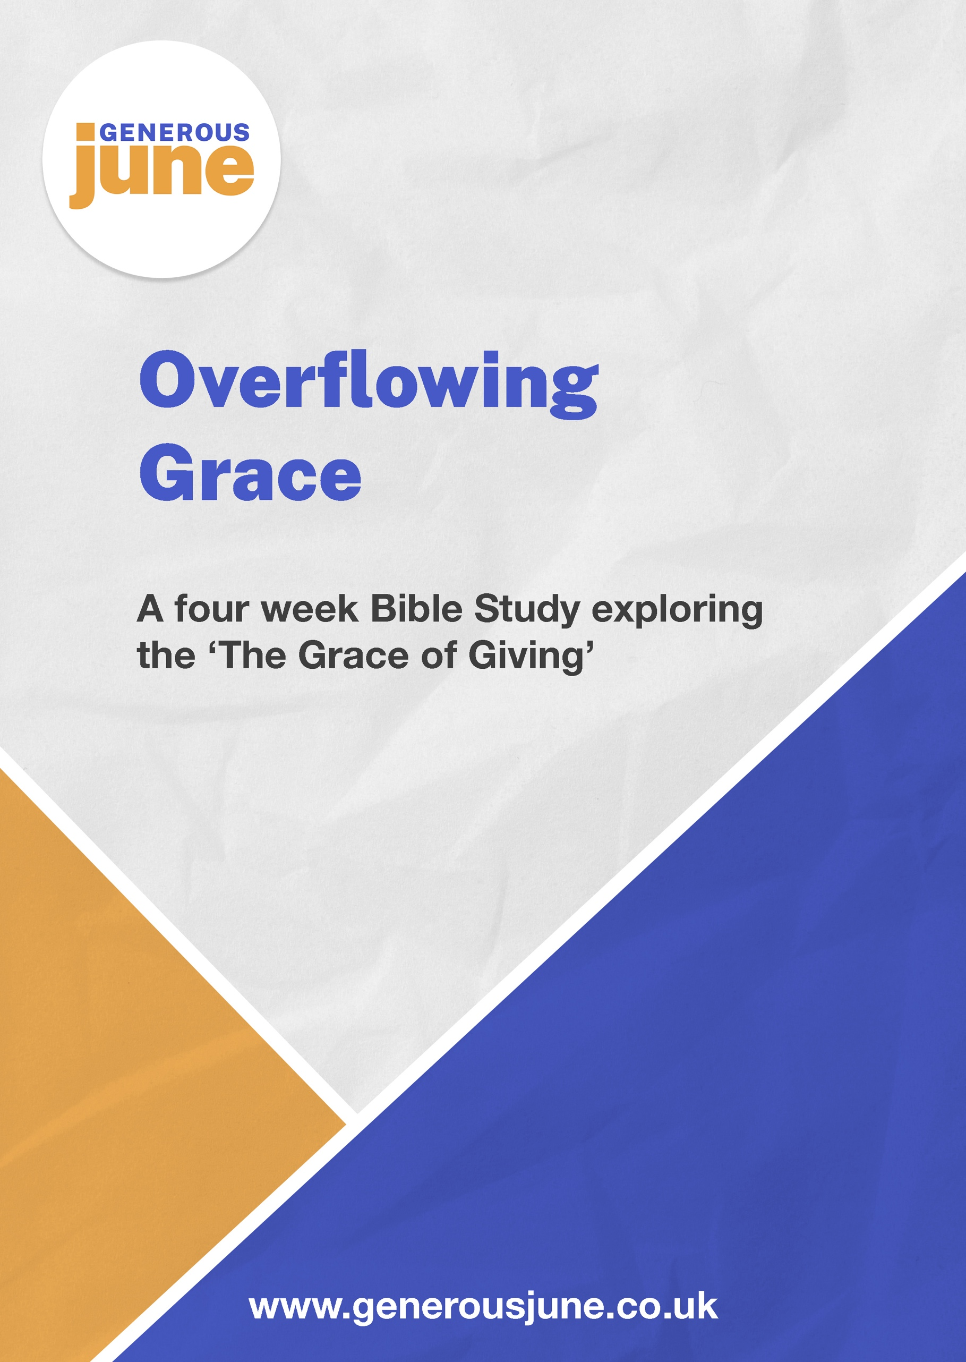

Leader’s introduction

Money is often a difficult thing to talk about. In our current
unprecedented time, the financial picture for many of us has
changed considerably, meaning that money might be an even
more difficult thing to talk about than usual.
The picture is clear: in these difficult times, churches, charities
and individuals are really struggling.

We believe that the bible has a great deal to say about money and
possessions and what we do with them. We have an important role
in helping those in our communities and responding generously to the
needs presented around us.

Paul, the great missionary apostle, was no different. An important part of his ministry was organising a financial offering from the Gentile churches for the poor in Jerusalem (Rom 15:25-28; 1 Cor 16:1-3). These three bible studies focus on Paul’s extended teaching in giving found in his second letter to the Corinthians chapters 8 and 9. As Paul wrote this letter, he was very concerned for the financial needs of the church in Jerusalem. Originally the church in Corinth had been enthusiastic to help, but their energy had flagged.

For Paul, the very real need in Jerusalem matters. But Paul also wants the Corinthians to know that their giving is a response to the overflowing grace of God, an act of obedience to Paul’s apostolic authority and a concrete expression of the mutual sharing between Jewish and gentile churches. With all this in mind, Paul tackles the thorny question of how to encourage the Corinthians to review their giving and get it back on track. It is amazing that he begins, not with a demand for money, but a discussion on grace. He does not even use the word, ‘money’ at all in the entire two chapters. Instead, he uses different words, such as fellowship, service and most importantly, grace.

Video resources to consider using:
https://www.youtube.com/watch?v=3lfPK2vfC54 Bible Project Overview
https://www.youtube.com/watch?v=62CliEkRCso Bible Project Generosity
https://www.youtube.com/watch?v=hXeb0q3GDfs Cheerful Giver Introduction
https://www.youtube.com/watch?v=4cs0gRxzKpY Francis Chan on Giving
https://www.youtube.com/watch?v=wh40S5XAc2Q Louise’s Generosity story
https://www.youtube.com/watch?v=LiBFufjbVFQ Chuma’s Generosity story

Session 1:
An introduction into generosity and giving

Use this session as a chance to engage in a relaxed
discussion around giving and generosity.

Starter: Would you rather

Ask the group a series of “Would You Rather” questions based around receiving (some examples below):
- Would you rather have your partner or friend cook your favourite meal or take you to your favourite restaurant?
- Would you rather be taken to the cinema to watch a new film by a friend or go on a walk to catch up with a friend?
- Would you rather get a personal present from a friend or family member for your birthday or a new expensive gadget?
- Would you rather organise your own birthday party so it’s just the way you want it or have your spouse/friend throw a surprise party for you?
- Would you rather receive a gift or a card saying that someone had donated to a good cause on your behalf?

Watch the following video together:

https://www.youtube.com/watch?v=62CliEkRCso - BibleProject Generosity
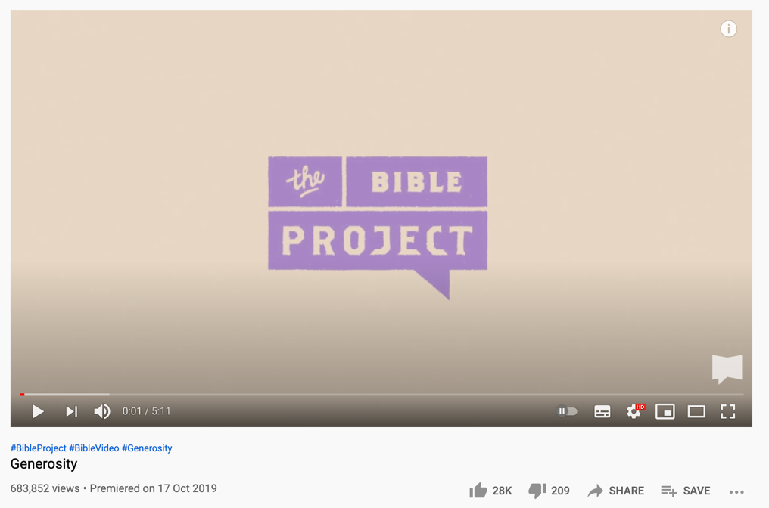

Session: 1
Page: 1

Read:

Acts 20:35 - In everything I did, I showed you that by this kind
of work we must help the weak, remembering the words the Lord
Jesus himself said: “it is more blessed to give than to receive”.

Ask the group to discuss this verse, with the following questions as
prompts:

- What is giving?
- What are the key principles of giving?
- What do people think about the following words in relationship to giving:
  - Purposefully
  - Proportionately
  - Cheerfully
  - Without show
  - Sacrificially
  - Freely
  - Generously
- Are there any other words that people consider important when we discuss giving?

Explain that over the next three weeks that you are going to be exploring as a group 2 Corinthians and the message of giving generously.

Pray together:

Ask the group to think in silence about a time when they have been shown generosity or shown generosity to others. Ask them to consider how it felt.

Ask the group to pray individually about their response to the words above in relation to giving. Pray together that God would provide more opportunities for the group to be generous and to consider their own responses to giving.

Session: 1
Page: 2
Session 2:
The example of grace – the generosity
of Jesus and the church in Macedonia

Starter:

- Have you ever received unexpected generosity?
- Have you ever found yourself prompted to give generously - especially from or to someone outside your own family or close friendship group?

Searching the Bible: Read 2 Corinthians 8:1-9

Prompts for discussion:

- One of the poorest churches, Macedonia, gave the most generously. Looking at verses 1-5 can you suggest why this might have been?
- In verse 8 Paul writes of, ‘testing the sincerity of your love’. Why does Paul consider that giving is somehow a litmus test of love and obedience for the Corinthians – and for us?
- We usually think about giving to meet needs. Looking at verse 9 what does Paul suggest is the ultimate motivation for Christian giving?

So, what now?

- What does this mean for us in the world, our church and our individual lives?
- The Macedonian church had experienced a severe trial (verse 2) and they were also extremely poor. What stories in the news of people and nations experiencing hardship and poverty are especially touching your heart at the moment?
- What would a church that ‘excelled in the grace of giving’ (verse 7) look like – and how does your church shape up?
- Can you share a time in your life when you have been challenged to connect your giving to your faith in Jesus?

Session: 2
Page: 1

Closing worship:

Read Philippians 2:1-11 and then spend some time in silence or
with a worship song playing quietly in the background.

- Does anyone have anything to share?

Taking action:

Find out about a charity that is supported by your local church and is working in a different part of the world – what more could be done to speak about the messages of these charities and causes?

Alternatively, you might like to think about the countries you may have visited or the stories you see on the news – can you find out more about the situations in these places and spend more time praying for the individuals and causes that are close to your heart?

Consider sharing or handing out copies of the following resource:

https://barnabasfund.org/resources/booklets/Praying-for-the-Persecuted-Church-2021-22.pdf

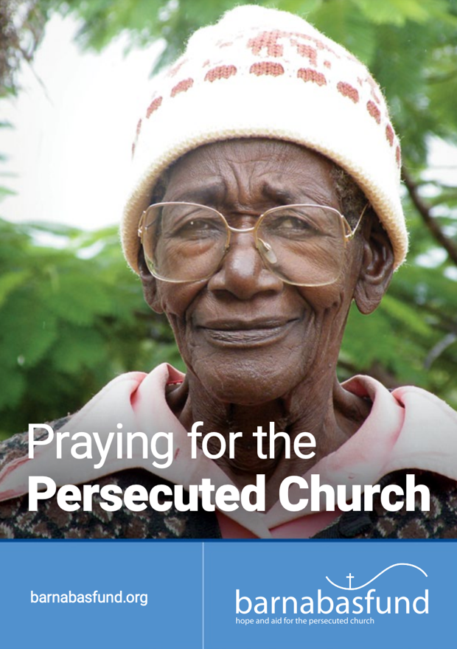
Session 3:
Session: 2
Page: 2

The practice of grace – graceful giving

Starter:

John Wesley said, “Earn all you can, give all you can, save all you can.”
- When you were growing up what money advice was passed on to you?
- Now that we are wiser (!) what money advice would we pass on to others?

Searching the Bible: Read 2 Corinthians 8:10-15 and 9:1-5

Prompts for discussion:

- Why do you think that Paul is willing to give advice about giving but will not command the Corinthians to do something?
- What does Paul mean in verse 12 when he talks of ‘giving from what you have’? Is it about giving from what we have left over when everything else is paid for or from our income as a whole?
- What does Paul mean by, ‘equality’ or ‘fair shares’ in verses 13-15? (You may find turning back to Exodus 16:18 quoted in verse 15, the story of Gods provision of manna in the desert, helpful.)
- Why in 8:11 and in 9:1-5 is Paul concerned that the desire to give is followed by practical action and planning to make their gift?
- How do we make decisions about spending in our church? What would be considered good and bad practice?

So, what now?

What does this mean for us in the world, our church and our individual lives? In this section we ask questions in each of these three areas.
- Why does the world have a short attention span regarding generosity to those in need once a crisis has faded from the news report or special days such as Comic Relief are over?
Session: 3
Page: 1
- Read 2 Cor 8:16-24. How does the way our church
communicate, manages and makes spending
decisions about money compare with the high standards
that Paul wants to set?

- Looking at our own giving in the light of 2 Cor 8:11 what is our
personal challenge: is it our willingness to give generously
or is it our ability to plan our giving and complete the task?

Closing worship:

Watch the following video together of ‘I the Lord of sea and sky’.

You may like to print out the words to make it easier to follow. There are two options to choose from:

https://www.youtube.com/watch?v=7LoMboxzm0U
https://www.youtube.com/watch?v=yv1arxTxy20&t=0s

Read 2 Corinthians 1:3,4 and 13:11. Leave a time for quiet prayer.

Taking action:

Paul talks about fair shares. Foodbanks are one way in which churches are meeting local needs through the generosity of individuals.

- This week find out more about what foodbanks do and how local churches are getting involved.
- Look for opportunities to give in some way each day this week – and do them cheerfully and in absolute privacy if at all possible.
- Look over your budget (or get started on making one) and consider how much and what proportion of your income you give away. How do you plan this so that you can keep charitable commitments?

Session: 3
Page: 2

Session 4:

The growth of grace – the outcome of giving

Starter:

Ask the group: If you had a million pounds right now, what would you do with it?

Searching the Bible: Read 2 Corinthians 9: 6-15

Prompts for discussion:

- What does the illustration of the sower teach us about giving?
- What does the passage suggest are the blessings and benefits of generous giving?
- Verse 8 is a tough verse. It promises God’s abundant provision so two tough questions:
- How do we feel about trusting God for everything that we need – and can anyone share a personal example of this?
- What advice would you give to someone in serious debt or money worry as they read this verse?

So, what now?

- What does this mean for us in the world, our church and our individual lives?
- Which charitable causes raise the most money – and why? What are the triggers that prompt your friends, colleagues and neighbours to give?
- How can your church help, ‘supply the needs of Gods people and overflow with thanks’. What would this look like week by week in services, small groups, community activities etc?
- Looking at these verses what words might we use to describe the heart of a generous Christian giver?

Session: 4
Page: 1

Closing worship:

Ask the group to offer prayers of thanks, avoiding asking God for
anything at this stage.

Explain that when there is a lull, you will leave a time of silence as
it is likely that more things for which to be thankful will occur to them
at this point.

You may wish to distribute a seed or a nut or even a small plant to each person and ask them to hold it and pray for guidance as to how to take part in sowing generously for God’s harvest. Ask for grace to be cheerful givers.

Taking action:

- Write down three practical steps that they can take to grow as a more generous and cheerful giver.

- Read Philippians 4:6 and spend a little time at the end of each day this week practicing an ‘attitude of gratitude’ for all the blessings that God has given you.
Session: 4
Page: 2
This Bible study was inspired by Giving In Grace, a comprehensive resource from the Diocese of Liverpool, designed to help develop a generous church culture, see more here:
www.givingingrace.org

